Background and Context
In global logistics networks:
- Late deliveries cause SLA breaches, penalties, and customer churn
- Reactive handling (after delays happen) is costly
- Early warnings allow proactive rerouting, reprioritization, or customer communication

While earlier project explains why delays happened, operations teams still need to know:
- Which orders are likely to be delayed before they are shipped ?

Problem Statement
APL Logistics faces challenges such as
- Unpredictable shipment delays
- High operational cost of last-minute fixes
- Limited ability to prioritize high-risk orders
The organization lacks
- A predictive system to flag late-delivery risk early
- Quantitative risk scores for operational planning
- Explainable insights into delay drivers

Data Science Methodology (Step-by-Step)
Data Preprocessing
- Handle missing and inconsistent values
- Encode categorical variables (One-Hot / Target Encoding)
- Scale numerical features
- Address class imbalance (SMOTE or class weights)
Feature Engineering
Create predictive indicators such as:
- Shipping pressure index (scheduled days vs quantity)
- Mode risk flags (express vs standard)
- Regional congestion indicators
- Order complexity score
Model Development
- Baseline Model
  - Logistic Regression (interpretability benchmark)
- Advanced Models
  - Random Forest Classifier
  - Gradient Boosting / XGBoost
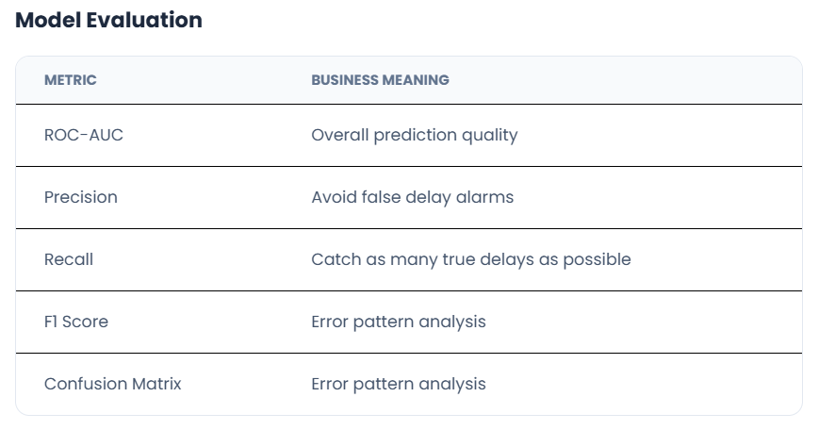
Risk Probability & Classification
- Each order receives:
  - Late Delivery Probability (0–1)
  - Risk Category:
    - Low Risk, Medium Risk, High Risk
Explainability & Insights
- Feature importance analysis
- Explanation of why an order is high risk
- Transparency for operational trust

